RUKC-SNA NEWSLETTER

  - July 2026
Board of Directors
OVP
President: Barbie Eckert
Vice President: Kristin Hatfield
Secretary: Zakiyyah Robinette
Treasurer: Stevie Meades
Membership Director: Omunique Harris
Events Coordinator: Mirla Motta
Historian: Zeinab Haidar

Special Committee Members: TBA

Faculty Advisor: Anne Naulty

TOPEKA

President: Ashley Hubbard
Vice President: Shawna Dicks
Secretary: Ayanna Johnson
Treasurer: Aaliyah Crawford
Historian: Annabel Barragan
Events Coordinator: Ayanna Etchinson
Member Coordinator: Erykah Nicholls

Faculty Advisor: Sandy Bergman

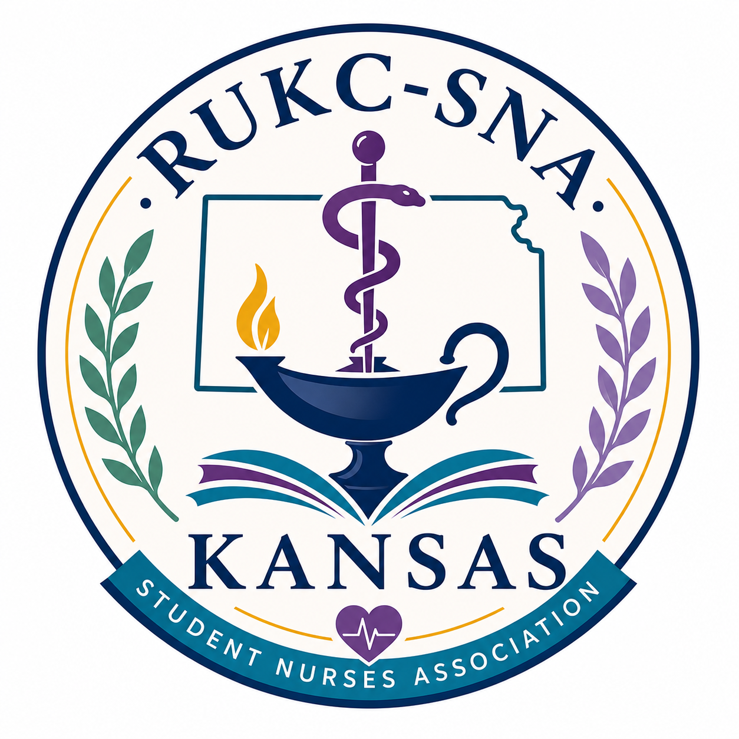

Student awards
Awards presented during the pinning ceremony:
Recognition awards/cords (members who earned over 20 participation points)
Leadership awards/cords: people who have served on the board
Daisy Awards (1 in OVP and 1 in Topeka)
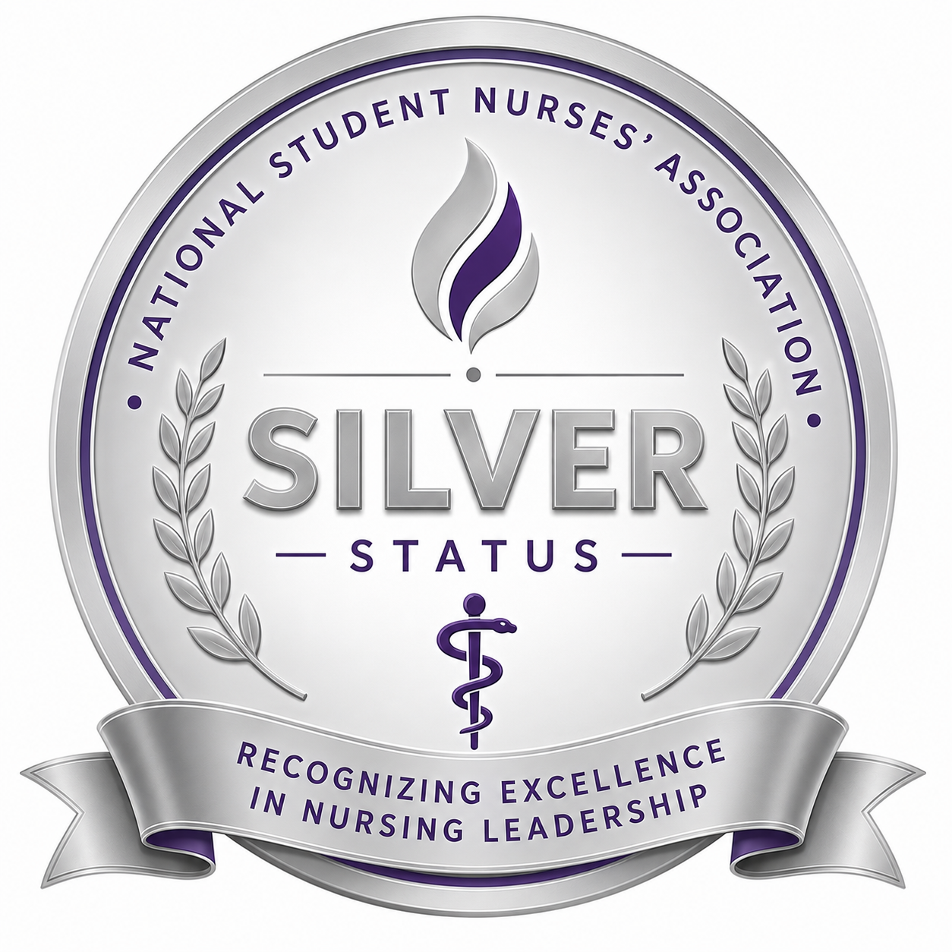
Other Awards/cords: Leadership, Most Determined, and Outstanding Team Player

Awards for the Graduating Class
Awards introduced this quarter for the graduating class are:

Leadership Award
Most Determined Award
Outstanding Team Player Award

Each graduating cohort will vote for their nominees in each category. Winners will be announced during the pinning ceremony in July!
We would like to congratulate our graduating class. Congratulations on your graduation from nursing school! Your hard work, dedication, and perseverance have led you to this incredible achievement. Countless hours of studying, clinicals, and caring for others have prepared you to make a meaningful difference in the lives of your patients and communities. As you begin your journey as a nurse, remember that your compassion, strength, and commitment are what truly make you exceptional. Wishing you success, confidence, and fulfillment in this exciting new chapter of your nursing career. The future of healthcare is brighter because of nurses like you!

WE ARE SEEKING BOARD MEMBERS
We are currently seeking board members for the Student Nurses Association (SNA)! If you’re passionate about making a difference, growing as a leader, and helping shape the future of our organization, this is your opportunity to step forward and get involved. Some positions are currently open! Positions on special committees are also periodically open. Please apply today

MEMBERSHIP DRIVE
Have you been considering joining the RUKC-SNA community? Now is the time to join us! We are here to accompany you through your nursing school journey! You will have support, friends, and fun! We are your fellow nursing students!
The RUKC-SNA is part of the Kansas Student Nurses Association and the National Student Nurses Association (NSNA). Imagine all of this networking and support in your new career!

To join, visit www.NSNA.org. Once you complete the membership application and pay the small fee, let us know and we will register you

A LETTER FROM THE NSNA
Dear NSNA Members in Kansas:
I would like to extend to you a warm greeting on behalf of the NSNA Board of Directors. My name is Cathy Ramos, NSNA Membership Specialist, and I would like to help you revitalize your state association.
According to NSNA records, the Kansas Association of Nursing Students (KANS) is currently not an official constituent of NSNA but has been in the past years. NSNA is currently working with Dr. Vicky McGrath, State Consultant, to regain their state constituency status.

Currently, there are 756 NSNA members from Kansas. KANS is seeking new student leaders to run for positions, so the state can revitalize their constituency status. I am writing to inquire if there is an interest in being part of KANS as a board member. Getting involved as a state leader entitles you to apply for the NSNA Leadership U Honor Society.

If YOU ARE INTERESTED, please complete the attached application form and submit to boardofdirectors.kans@gmail.com by August 31st, 2026. If you have any questions reach out to Dr. Vicky McGrath at director@ksnurses.com.

Please note that RUKC-SNA is supporting KANS in the effort to rebuild. Our OVP Faculty Advisor, Anne Naulty, has been in contact with both Cathy Ramos (NSNA) and Dr. Vicky McGrath (Kansas Nurses’ Association). More information to come.

The Daisy Award for Nursing Students
The DAISY Award for Nursing Students recognizes those who demonstrate exceptional compassion, clinical skill, professionalism, and dedication to patient-centered care. This special honor celebrates students who go above and beyond to make a meaningful difference for patients, families, peers, and the healthcare team. Nominations are now open for the June cohort, and we encourage you to take a moment to recognize a classmate who exemplifies the values of nursing excellence. If you have witnessed a fellow student showing kindness, leadership, teamwork, or outstanding commitment in clinical or the classroom, please submit a nomination and help celebrate their impact. Please note that all nominations must be from the June 2026 Cohort.
Please cast your vote at the RUKC-SNA table on the campus.
Daisy Award for Nursing Instructors
The DAISY Award for Outstanding Nursing Instructors is awarded every June and December. There is one award for the Topeka location and one award for the Overland Park location. Please cast your vote!
Topeka News  Contribute to the My Little Pantry and earn points! Please feel free to take what you need or donate what you can. When you donate, you earn points!  Find Razzy and take a picture with him. He is hiding around campus. Send the picture to either Ashley or the RUKC email and earn points! Make sure you let us know what campus you are on!  Cheers to our Peers poster is available. Write a note of appreciation to a colleague and post it on the board.  The winner of the May raffle was announced on May 15th! Congratulations!  A finals week mixer is scheduled for June 12th. | Overland Park News  Contribute to the My Little Pantry and earn points! Please feel free to take what you need or donate what you can.  Garage sales will continue throughout the quarter. Please watch for further announcements. We have a few more t-shirts available for purchase.  We are planning a chicken wing celebration in June in honor of finals week.  The Cheers to our Peers posters are filling up! Please take a minute to celebrate and thank a colleague.  Razzy continues to hide around campus. Find him and take a picture with him. Send the picture to either Barbie or to the RUKC email to earn points!  The 5k was a success! Thank you to everyone who participated.
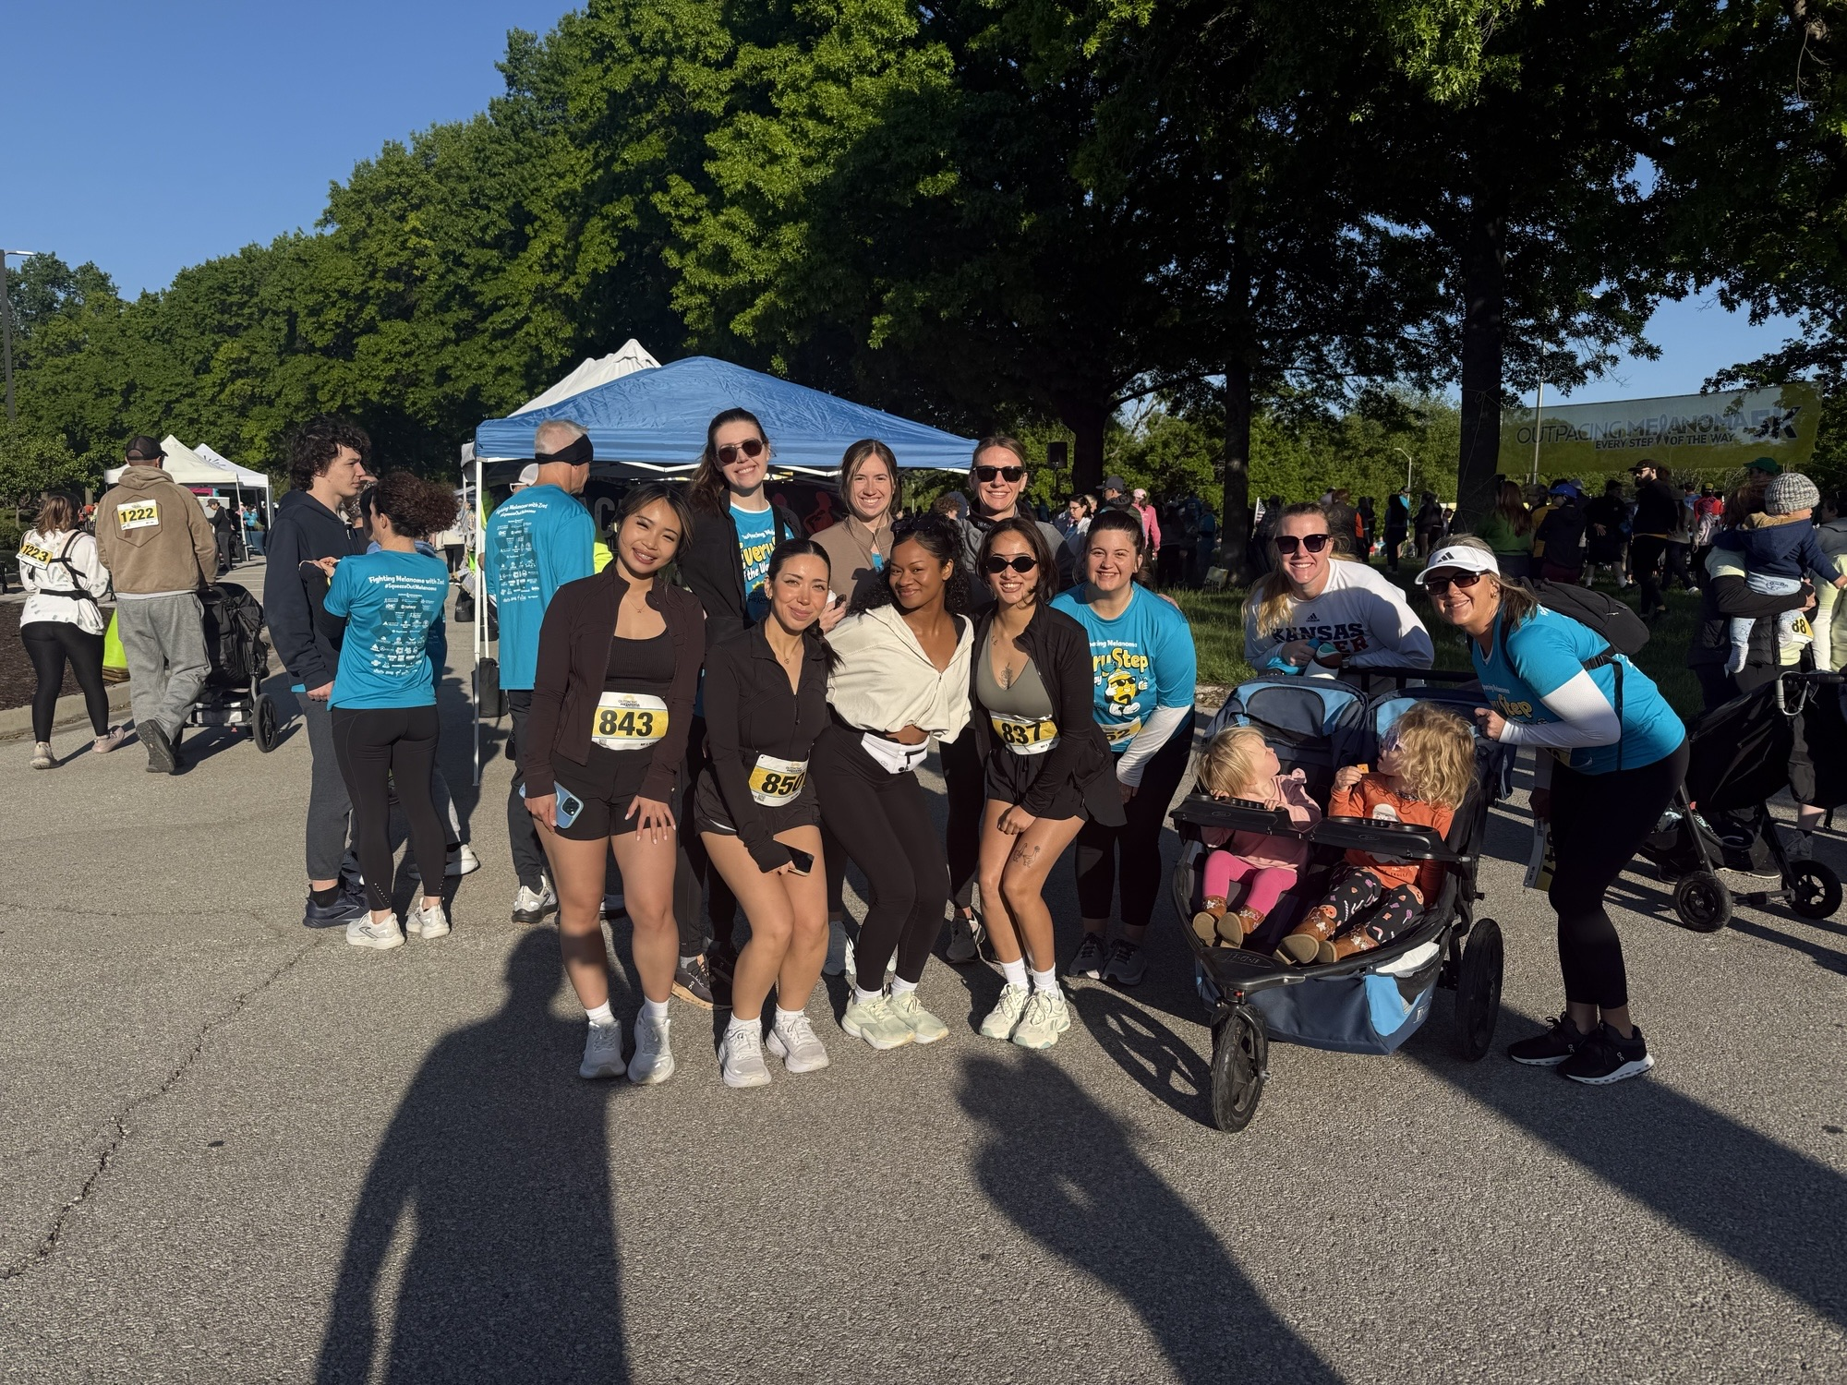

THE RUKC-SNA Point System

Our student nurses' association partners up with many area businesses and agencies. Volunteering is one way to give back to the community and earn points. Together we can make a difference in our communities!
Together we are better!

Examples of ways to earn points:  Write an article for the Chapter Newsletter  Earn 2 points per article  Volunteer at one of our sponsored events  Earn 1 point per hour of volunteer time (up  to 8 hours per quarter)  Donate food to the “My Little Pantry.” Earn points every time you donate.  Attend Chapter Meetings  Earn 1 point for attending each monthly  chapter meeting  Serve As a member of the Chapter Board of Directors  Earn 2+ points per quarter that you serve as a  Member of the Board  Earn 1 point for attendance at each monthly member meeting  Donate items to the campus garage sales and earn points!  Find Razzy on Campus and take a picture – send it to the RUKC-SNA email - 1 point | When You Graduate  When you are almost ready to graduate, add up all of your points that you have earned over the quarters that you have been a member of the RUKC-SNA. Submit your total number of points earned and the activities you participated in to the SNA or faculty advisor.  NSNA Chapter Leadership Cords are awarded to all members of the Board.  Chapter cords are awarded to any member who has earned 20 or more points.  For more information about the point system, please visit www.rukc-sna.com or talk to one of the board members or our faculty advisors.

Cheers to our peers Board Messages

Board Member Spotlight
Short Bio: My name is Ayanna Johnson, though I prefer to go by my married name, Ayanna Happel. I am 27 years old and have a strong passion for providing compassionate care to others. I am committed to giving my best in all that I do and continuously strive for excellence.
In my free time, I enjoy reading, long walks and runs, cooking for others, and writing. I am truly excited for the opportunity to serve in a role where I can make a meaningful and lasting impact.
Ayanna is currently serving as the Secretary at the Topeka, Kansas location.

Sharing some of the messages from the peers boards:
Jas & Leah
So proud of you guys! Praying for your journey.

LIV
My first nursing school bestie! Thank you for being a part of my circle. You are going to make the most caring nurse. Your hard work is admirable. Love you! ~Britt

Kendra
You have a heart of golf. Your perserverance if admirable. Don’t lose that sparkle. It inspires us all! ~Bailey

Emma
You are such a fun and positive vibe. It honestly makes being around you so enjoyable-even on the long and tiring days. ~Hiba

Derek
Thank you for taking the time to teach me when you don’t have to. You make things easier to understand. I’m really grateful for that! ~Kendra

Shatasha
I admire your hard work and determination! You inspire me! ~Barbie

YK
Can’t nobody stop you but you! WE GOT THIS!

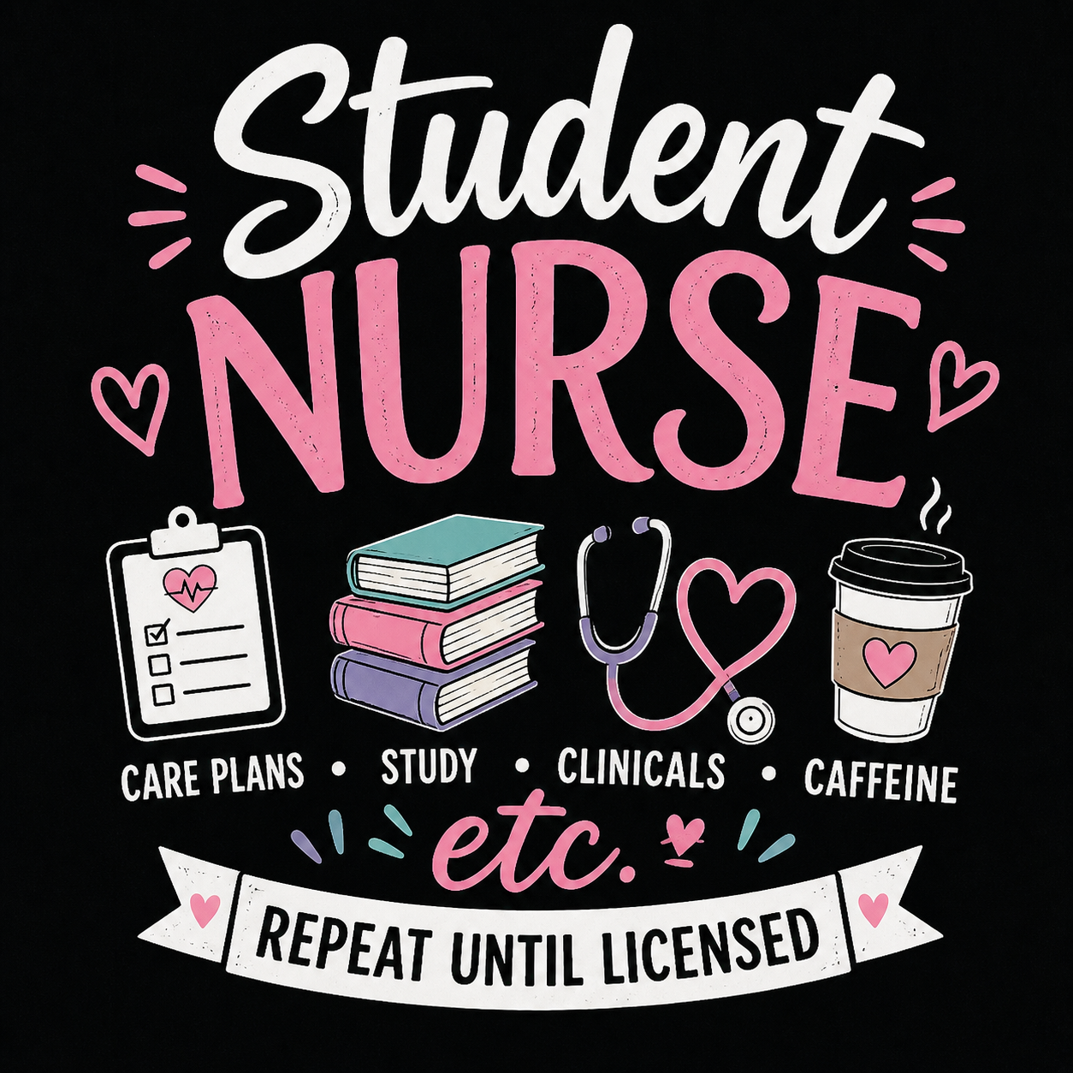
The Benefits of Joining the NSNA
There are many reasons to join the NSNA. Joining the National Student Nurses’ Association (NSNA) provides nursing students with valuable opportunities to grow professionally, academically, and personally. Membership offers access to leadership development experiences, scholarships, networking with peers and nurse leaders across the country, and resources that support success in nursing school and beyond. Students can participate in conferences, community health initiatives, and advocacy efforts that strengthen their voice in the future of nursing. Involvement in NSNA also helps build confidence, enhance resumes, and create meaningful connections that can open doors to mentorship and career opportunities after graduation. discounts.
Important Dates  June 15-19: Final Exam Week  June 19th: Last Day of the SP26 Quarter  June 20- July 5th : Break Weeks  July 6th: Summer 26 Quarter Begins  Dosage calculation quiz week  July 10th: Pinning Ceremonies in Lawrence,  Kansas | 

Preparing for Finals
Preparing for finals requires organization, consistency, and self-care.
Start by creating a study schedule that breaks down subjects into manageable sections so you can review a little each day instead of cramming at the last minute.
Focus on understanding key concepts, reviewing notes, practicing questions, and using study guides or flashcards to reinforce learning.
It is also important to eliminate distractions and create a quiet study environment that helps you stay focused.
In addition to studying, make sure to get enough sleep, eat healthy meals, stay hydrated, and take short breaks to avoid burnout.
Staying positive and confident can reduce stress and improve concentration, helping you perform your best during finals week.
Remember to take care of yourself during this period.

Have a great break!

