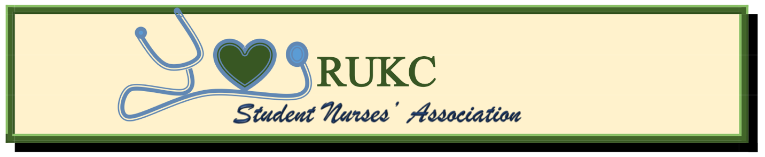

Meeting of the Board of Directors May 30, 2021. Via Webex.

1. Call to Order: The regular meeting of the Board of Directors of the RUKC-SNA was called to order by Blair Gordon, Vice-President (standing in for Jennifer Cristaldo, President), at 6:05 pm.
2. Those Present: Blair Gordon, Vice-president, Beth McNatt, Secretary, Kathryn Kieft, Treasurer, Jessica Mock, Topeka membership coordinator, Stephanie Miles, Historian, and Professor Anne Naulty.
Quorum: Beth McNatt, secretary, declared a quorum present.

3. Minutes: The minutes of the previous meeting were read and approved as read (or corrected).

4. Treasurer’s Report: Bank account still needs to be opened in two board members’ names. President and Treasurer will be responsible to open SNA bank account and will be its formal signers. Bank account should be opened at location which will be accessible to both OVP and Topeka campuses.

5. Report of officers:
- Jennifer Cristaldo, president, not present.
- Blair Gordon, vice-president: Suggests that the next SNA general membership meeting be held over the break before the next summer quarter begins.
  - When are we going to start implementing dues for local chapter membership from SNA members?
    - Professor Naulty suggests using the “Points system”, in which points are given for participation with chapter. Examples are a certain number of points would be given for writing article for newsletter, attending events, being board members, attending meetings, etc. to earn items like cords, etc.
  - Regarding Big Brothers/Big Sisters program: Blair has a letter with requirements, still waiting for faculty approval of system.
    - Proposes a 2 pt. system for bigs/1 pt. for littles/per quarter. And Pathophysiology as a gateway class to be a little. Littles should have a 3.0 gpa and commit to being a Big upon completion of MDCII.
6.Unfinished Business:
- Discussion of creating/filming a RUKC-SNA video for media advertisement. It is suggested by Jessica Mock that each member should record themselves individually and submit to (someone?) for splicing into one video. Goal is to accomplish this before June 2021 graduation.
- Professor Naulty is still working on our website for our RUKC-SNA chapter. Thank you!
- Blair Gordon and Danielle Fleshman are working on setting up a Facebook page for our RUKC-SNA chapter. Blair reports that it’s done but not set up for *joins* yet.
- Discussion regarding how to replace graduating SNA board members Blair Gordon suggests that we advertise to SNA members in advance for upcoming open board member positions since three are opening in June: Vice-President position will be filled by Jessica Mock, leaving her position of Topeka membership coordinator open. Secretary position will be open, and OVP events-coordinator will be open as well. Positions should be opened to current board members first.
  - Applications need to be created for each board position with job descriptions and board member requirements stipulated. It is agreed that a gpa of 3.0 is required, as well them expressing why they’re interested and verifying that they are willing to attend every scheduled meeting.
    - Jessica Mock volunteers to do this. Blair Gordon will email her the information to compile. Jessica will complete and send to Anne Naulty.
- Discussion of how to dismiss and replace current board members if too many meetings missed (more than two per quarter) or gpa drops too low.

7.New Business:
- A more efficient way to communicate announcements to SNA members is needed.
- Date for next SNA General Membership meeting needs to be discussed and decided.
- Professor Naulty suggests that we begin designing/writing a monthly newsletter to be sent to all RUKC nursing students after having been submitted to the Dean for approval.
- Jessica Mock: Point system needs to be discussed: Members will need to email membership coordinators to keep track of volunteer hours, etc. Members will be responsible to let them know after each event. Point system legend is needed to delineate what and how points are to be allotted.
- “Chain of Command” issue needs to be addressed to students, since there is significant confusion on the matter.
- Stephanie Miles suggests that SNA devise a way for members to submit their suggestions, questions, and concerns to the board members. Possibly on Facebook page? RUKC website? Should there be a Q&A section in SNA’s monthly newsletter?

8. It is agreed that our next board meetings will be on Sunday, June 13, 2021 at 6 pm.

9. Professor Naulty reminds all new board members to please submit their articles to her for our upcoming newsletter by Tuesday, June 15th.

10. Adjournment: There being no further business, the meeting was adjourned by Blair Gordon, vice-president, at 7:28 pm.

(President Signature–can be scanned)__

(Secretary Signature–can be scanned)
______________________________________________________________________________

