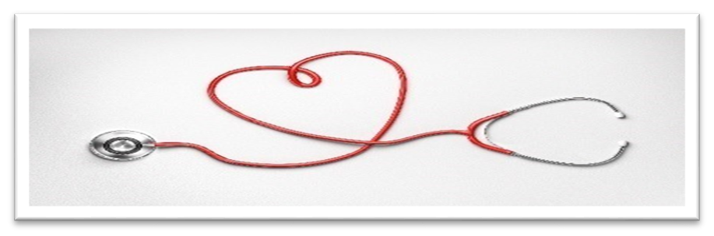
RUKC Student Nurses’ Association
Meeting of the Board of Directors Sunday, December 19th, 2021 via “Zoom”
- Call to order: The regular meeting of the Board of Directors of the RUKC-SNA was called to order by Cassie Dreher, President, at 6:08 p.m.
- Those present: Cassie Dreher, President, La Star Jones, Treasurer, Izzy Walters, Secretary, Kalissa Sternicki, Special Events Coordinator (Topeka) + Jessica Mock, Alumni.
- Treasury Notes: La Star Jones opened an account with the bank (name in email) and filed paperwork on 10/22/21 with Business Entity ID #6766059. 1023-EZ Form, sent to bank. Bank account is now open!
- Previous minutes discussed.
- Items Discussed:
-Bank account is now open! Per Jessica, there are two checks at Topeka campus that need to be deposited for t-shirt funds.
-Kalissa and Samantha to re-decorate tables at OVP and Topeka campuses. Needing the new SNA newsletters printed by front desk to place on tables. SNA mailbox now at Topeka campus.
-Cassie needing to ask Dean for space at either campus for storage (i.e. table decorations).
-Luke ordered t-shirts for the Virtual Fun Run. Cassie to send Luke envelopes to mail shirts.
-Kalissa and Samantha are planning on 3 different challenges for each month in this quarter, water challenge in January with cohorts and faculty sponsors.
-Jessica to add to accounting Excel spreadsheet made by LaStar, needing to be put on a Google shared document.
-Apply for the NSNA Leadership U Honor Society today! https://form.jotform.com/nsnainc/nsna-leadership-u-honor-society-app link to form.
-Children’s Mercy “happy kits” will be made with supply donation boxes out at each campus, $28 budget set, and Butter Braid fundraiser to happen in February, https://butterbraid.com/products/ link to website.
-Alumni Excel spreadsheet will be sent by Izzy to new graduates to fill out if they wish to keep attending SNA meetings.
-Jessica to send list of ideas for SNA newsletter articles + suggestion to add article on water challenge in January, Butter Braid fundraiser (possibly in February) and “happy kits” for Children’s Mercy.
-Cassie offered her Dad’s venue 503 Winery and Event Center in St Joseph, Missouri https://www.503wineryandeventcenter.com for the nursing student gala.
-Scholarship application voted in favor by Board of Directors to pay for student NSNA membership, article to be made by Cassie for SNA newsletter. Idea to make this a quarterly goal.
-Idea presented via email by Kalissa to have therapy dogs on campus. Would need to get approval from Dean. For reference, KU event https://www.launchku.org/project/1739.
6. Next meeting agenda:
-Discuss unfinished business as stated above.
-Setting budgets for projects.
-Time and event management.
-General member meeting agendas.
7. VOTING:
- Adding a position for Jessica Mock as Board Member Advisor.
8. Open Positions:
-Membership Coordinator, Overland Park and Topeka campuses.
9. Upcoming Meetings:
-General Members (4th Sunday of every month at 5 p.m):
-01/23/22 at 5 p.m.
-02/27/22 at 5 p.m.
-Board of Directors:
-01/02/22 at 5 p.m.
-01/16/22 at 6 p.m.
-01/30/22 at 6 p.m.
-02/13/22 at 6 p.m.
-02/27/22 at 6 p.m.
-03/13/22 at 6 p.m.
10. There was no further business to discuss. The meeting concluded around 7:15 p.m.
X ___________________________________________ President (Scanned accepted)
X__________________________________________
Secretary (Scanned accepted)
Happy New Year!
Wishing everyone good luck in the upcoming quarter!


