

RUKC-
Student Nurses’
Association

Membership Information
Prepared by the Board of Directors and Faculty Advisor

“Keep your face always towards the sunshine and shadows will fall behind you.”
~Walt Whitman

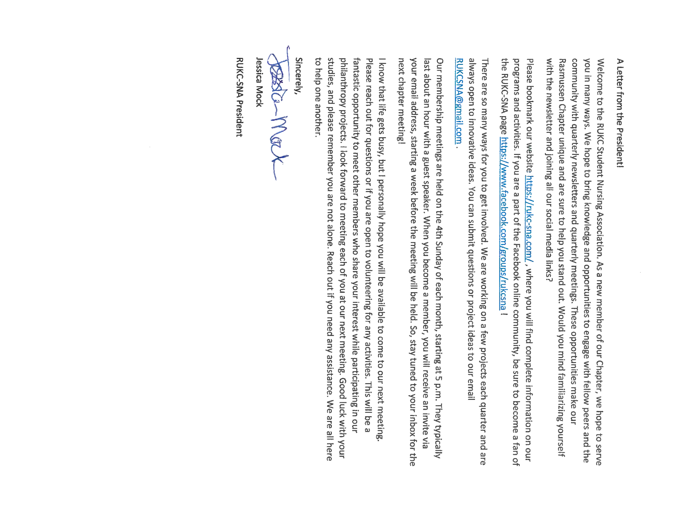

A Family of Organizations

National Student Nurses’ Association (NSNA)
The NSNA was founded in 1952 with some help from the American Nurses Association (ANA) and the National League for Nurses (NLN). NSNA is a not-for-profit organization which is governed by nursing students from all over the United States. Membership is open to all pre-nursing degree students, undergraduate nursing students, RN to BSN students, generic masters and doctoral nursing programs (NSNA, 2021). The NSNA has over 60,000 members in the United States, Guam, The District of Columbia, Puerto Rico, and the U.S. Virgin Islands.
The NSNA’s Mission has many layers. The members of this organization support and advocate for various components of nursing education on every level. The organization also stands for affordable, accessible, high-quality healthcare for all. The NSNA helps to teach and solidify leadership skills of nursing students who participate in the organization.
The NSNA also members many benefits. Some of these benefits include discounts on study tools, nursing organizations, hotels, insurance, and select school supplies. The NSNA also offers a Leadership University, conventions, conferences, committees, and many programs. We believe it is an amazing organization.
Membership comes in many levels. If you are a pre-nursing student, you are able to join the NSNA as an Associate Member. If you are already enrolled in a nursing program, you are eligible for an Active Membership. If you would like to support the mission of the NSNA, but you do not qualify for the Associate of Active Membership, you are able to join as a Sustaining Member. For more information on membership, please visit the NSNA website or speak to one of the RUKC-SNA Board of Directors.
All Associate Members of the NSNA are able to run for and hold offices in the national organization.

Kansas Association of Nursing Students (KANS)
Since our Rasmussen Campus is located in Overland Park and Topeka, Kansas, we are able to be a part of the Kansas Association of Nursing Students (KANS). The Kansas Association of Nursing Students hosts a yearly state convention as well as other activities. KANS is also run by a Board of Directors that is composed of nursing students across the state of Kansas. When you join the NSNA, you are able to also join KANS for a small fee. This helps to bring the experience a little closer to home.

Rasmussen University Kansas Chapter-Student Nurses’ Association (RUKC-SNA)
RUKC-SNA was originally formed in late 2019 as a way for Kansas Rasmussen nursing students to advocate and support each other. In early 2020, we formed our first board of directors and submitted our formal bylaws to the NSNA. It was at this time we applied for our Chapter’s Constituency Status through the NSNA. In April 2021, we were officially recognized and given constituency status by the NSNA during the annual convention. By April 2021, our chapter had 35 members and it continues to grow.

Alumni Association
After you graduate with your nursing degree, you have the opportunity to continue as a member with the RUKC Alumni Organization. At this time, there are no dues to belong to this organization.

More about RUKC-SNA

The Board of Directors
The Board of Directors consists of a President, Vice President, Treasurer, Secretary, Membership Coordinator-OVP, Membership Coordinator-TOP, Special Events Coordinator-OVP, Special Events Coordinator-TOP, and a Historian. We also have a Faculty Advisor, a Faculty Liaison-OVP, and a Faculty Liaison-TOP. Each of the Members of the Board have specific tasks. These tasks are outlined in our Chapter By-Laws (see appendix a).
Since our students graduate each quarter, we have elections for open board positions most quarters. When the positions of President or Vice President are open, the current board members have the opportunity to fill these positions first. If no board member is interested, then the positions are open for members to apply.

Special Committees
Special committees may be formed at any time. Special Committees are composed of members that want to serve in leadership roles and help support the cause. Being a part of a special committee is a lot of fun and you are able to work together with other members. This is a great way to make long lasting friendships!

The Roles of the Association
The RUKC-SNA has many roles. One of the largest roles is acting as the liaison between faculty and students. When students have concerns, they are able to discuss them with a member of the Board, who is usually the President or Vice President. The Board member then brings the concern to the Board. Once the Board has discussed the matter, then the issue may be brought up in a faculty meeting by a representative of the Board. This is a very efficient way to get things done and progress is made.
Once the issue has a resolution, the President or Vice President usually gets in contact with the student. It is important to note that any issues brought to the Board should not be specific to one student. The issues usually effect the entire student body or the members in one cohort. It is also important to note that no students’ names are mentioned when the Board brings the issue to the faculty meeting.
RUKC-SNA also sponsors many activities throughout the school year. Activities are a great time for students to get together and get to know each other. Some of the activities help the communities we are in, while some help the organization reach its goals to help nursing students. All of our events are in line with the mission and vision of the University .RUKC may sponsor a pizza party during exam week, have giveaways, help community non-profit organizations, and so much more. We are always open to new ideas!
Some of the activities we have sponsored include:
- Our Little Free Pantry: Whether students need food or want to give food, there is a pantry at each campus.
- Bi-Monthly Newsletter: Keep in touch with what is going on!
- Study Sessions: Sometimes we all need a little help from our friends. Nursing school is so much more fun when studying becomes a team effort.
- Big-Little Program: A senior student is paired with a junior. This support is great for both nursing students.
- Monthly Seminars and Presentations: Every monthly membership meeting includes an inspirational and/or informative speaker.
- The Virtual Fall Fun Run: A great way to promote movement, make new friends, and help the organization.
- Fall Food Drive: As a student body, we collect non-perishable food for a community agency. Each Fall the members decide who to give the donations to.
- Scrubs and Sneakers: A virtual fun run that is sponsored by the FNSNA.
- Monthly Membership Meetings: These ae held either online or in person.
- Chapter t-shirts and other items
- The Tree if Joy
- Point System for participation in chapter events
- Health and Wellness Challenges
- The RUKC Alumni Association
The bi-monthly newsletter are distributed thru student email. Paper copies are also available at each campus. We have found this is our best way to reach students.

Professional Outreach
Professional outreach is very important to our chapter and to the faculty. Thru our members, alumni, and faculty, we are able to keep in touch with many nursing organizations. This not only keeps us informed, however it adds to our academic learning. We are also able to contribute to causes, such as the FNSNA Scrubs and Sneakers Virtual Run.
As a chapter, we work to stay active with the Kansas Association of Nursing Students (KANS). It is our goal to be able to send at least one representative from each campus to the annual state convention. We also invite the president of the organization to speak at one of our monthly member meetings annually. This is a great time to find out what is going on within the profession and nursing academics in the state of Kansas.
We are also involved with the National Students’ Nurses Association (NSNA). Through this national organization, we are able to attend leadership conferences, apply for scholarships, attend national conferences, network with other student nurses’ associations across the country, serve on committees, prepare for licensure, advocate for nursing education, and more. We support our members who choose to go to conferences held by the NSNA. Our chapter is also an official voting chapter for the national organization.
Through our faculty advisor and by becoming a student subscriber, we also are in contact with the American Nurses’ Association (ANA) and the Kansas State Nurses’ Association. These organizations enable us to find out what is going on in the profession, plus we are able to meet many of the leaders in nursing.
The networking list does not end there! Through special events and faculty members, we are also able to connect with other professional nursing organizations. Some of these organizations are the Association of Operating Room Nurses (AORN), American Holistic Nurses’ Association (AHNA), Emergency Nurses’ Association (ANA), American Association of Critical-Care Nurses (AACN) and more! This is a great way to begin a nursing career!
During our monthly membership meetings, we also invite many professional guest speakers. Speakers are chosen based on student demand, past presentations, and accessibility. The information never ends. As an organization and personally, we are creating a network that we can build our nursing careers on.
Meeting You
We look forward to meeting and getting to know you! Each of us entered the field of nursing for different reasons. The majority of us want to make a difference in another person’s life. We are healers, however we must also take care of ourselves. Together we are able to help each other, support each other, and promote each other. We want you to know we are here for you.
We will end our booklet with a current copy of our chapter bylaws. If you ever have any questions, please contact any of the board members, our faculty advisor, or our faculty liaisons. You can also email the board at RUKCSNA@yahoo.com.

Appendix A
RUKC-SNA Bylaws

ByLAWS FOR THE NSNA RASMUSSEN University- KANSAS CHAPTER student nurses association (RUKC-SNA)
Note: Areas of conformity with NSNA Bylaws are in BOLD print.
(These bolded areas must be in school chapter bylaws in order to be an NSNA chapter.)

Article I - NAME OF ORGANIZATION

Section 1. The name of this organization shall be the RASMUSSEN UNIVERSITY- KANSAS CHAPTER-Student Nurses Association (RUKC-SNA).

ARTICLE II - Purpose of Function

Section 1. Purpose
- To assume responsibility for contributing to nursing education in order to provide for the highest quality of health care.

- To provide programs representative of fundamental interests and concerns to nursing students.

- To aid in the development of the whole person, his/her professional role, his/her responsibility for the health care of people in all walks of life.

Section 2. Function
- To have direct input into standards of nursing education and influence the education process.

- To influence health care, nursing education and practice through legislative activities as appropriate.

- To promote and encourage participation in community affairs and activities towards health care and the resolution of related social issues.

- To represent nursing students to the consumer, to institutions, and other organizations.

- To promote and encourage students' participation in interdisciplinary activities.

- To promote and encourage recruitment efforts, participation in student activities, and educational opportunities regardless of a person's race, color, creed, national origin, ethnicity, age, gender, marital status, lifestyle, disability or economic status.

- To promote and encourage collaborative relationships with nursing and health-related organizations.

Article III - MEMBERS
Section 1. School Constituent
- School constituent membership is composed of active and/or associate members of the NSNA and the state association when one exists.

- Rasmussen University Kansas Chapter-Student Nurses Association (RUKC-SNA) Shall be composed of at least ten members from Rasmussen College- Kansas Campus or the total school enrollment if less than 10. There shall be only one chapter on this school campus. The school campus includes both the Topeka and Overland Park locations.

- For yearly recognition as a constituent, an officer of the Rasmussen University Kansas Chapter- Student Nurses Association shall annually submit the Official Application for NSNA Constituency Status which shall include the following areas of conformity: purpose and function (NSNA Bylaws Article III), membership (NSNA Bylaws Article IV), representation to NSNA meetings (NSNA Bylaws Article VII). This information must be received by the NSNA by February 1st of each year to be considered.

- A constituent association which fails to comply with the bylaws and policies of NSNA shall have its status as a constituent revoked by a 2/3 vote of the NSNA Board of Directors, provided that written notice of the proposed revocation has been given at least two months prior to the vote, and the constituent association is given an opportunity to be heard.

- Rasmussen University Kansas Chapter- Student Nurses Association is an entity separate and apart from NSNA and its administration of activities, with NSNA or Kansas Association of Nursing Students (KANS) exercising no supervision or control over these immediate daily and regular activities. NSNA and KANS have no liability for any loss, damages, or injuries sustained by third parties as a result of the negligence or acts of RUKC-SNA or the members thereof. In the event any legal proceedings are brought against NSNA and KANS, RUKC-SNA will indemnify and hold harmless the NSNA and KANS from any liability.

Section 2. Categories of Constituent Membership
Members of the constituent associations shall be:

- Active members:
- Students enrolled in state-approved programs leading to initial licensure as a registered nurse.
- Registered nurses enrolled in programs leading a baccalaureate degree with a major in nursing.
- Active members shall have all the privileges of membership.

- Associate members:
- Pre-nursing students, including registered nurses, enrolled in college or university programs designed as preparation for entrance into a program leading to an associate degree, diploma or baccalaureate degree in nursing.
- Associate members shall have all of the privileges of membership except the right to hold office as president or vice president at state and national levels.

C. Individual members:
Individual membership shall be open at the national level to any eligible
student when membership in a constituent association is not available.
Individual members shall have the privileges of membership as prescribed in
NSNA bylaws.

D. Active and associate membership shall be renewable annually.

Section 3: Extension of Membership
Active and associate NSNA membership may be extended six months beyond graduation from a student's program in nursing, providing membership was renewed while the student was enrolled in a nursing program.

Article IV - DUES

Section 1.
- The Annual NSNA dues for active and associate members shall be $30 per member, plus $10 state and $25 school dues, payable for the appropriate dues year. The dues year for membership shall be a period of twelve consecutive months.

- The annual NSNA dues for active and associate members joining for two years shall be $50 per member, plus $15 state and $40 school dues, payable for the appropriate dues years. The dues years for these members shall be a period of twenty-four consecutive months.

- The school association board of directors shall have the authority to change school chapter membership dues; providing such dues do not exceed the amounts set in these bylaws.

- National and state dues shall be payable directly to NSNA. NSNA shall remit to each state constituent the dues received on behalf of the constituent. NSNA shall not collect nor remit school chapter dues.

- Rasmussen University Kansas Chapter- Student Nurses Association (RUKC-SNA) dues will be payable directly to RUKC-SNA.

- Any member who fails to pay current dues shall forfeit all privileges of membership.

Article V. - Board of Directors
Section 1. Composition
- The RUKC-SNA Board of Directors will consist of: President, Vice President, Secretary, Treasurer, Topeka Membership Coordinator, Overland Park Membership Coordinator, Topeka Special Events Coordinator, Overland Park Special Events Coordinator and a Historian.
- The RUKC Alumni Coordinator will serve as a Board of Directors Honorary Member. The Alumni Coordinator will have no voting privileges.
- All RUKC-SNA Board members must be registered students in good standing at Topeka or Overland Park Rasmussen in the School of Nursing.

Section 2. Collective Responsibilities
A. The Board of Directors shall be responsible for:
- Transacting business of the association between membership meetings. The Board shall report such transactions at the next regularly scheduled membership meeting.

- Filling vacancies in any office by a two-thirds majority vote of Board of Directors.

- Reviewing expenditures, revenues, policies and procedures, and any other business of the association.

Section 2. Quorum
A quorum for the board meetings shall be the president or vice president, two other board members, and one faculty advisor.

Section 3. Duties of the Board of Directors shall consist of:
A. President
- Shall preside at all meetings of this association, appoint committees as needed, perform all other duties pertaining to the office and represent this association as needed.
- Shall serve as chairperson of the General Member meetings.

B. Vice President
- Shall assume the responsibility of the office of President in the event of the vacancy occurring in the office until the next regular election.
- Shall preside at member meetings in the absence of the President.
- Shall assist the President as needed.

C. Secretary
- Shall read, understand and follow NSNA Secretary Guidelines as outlined: https://www.dropbox.com/s/io1asnlotkrjmdw/Secretaries%20Guidelines.pdf?dl=0
- Shall record and distribute the minutes of all meetings as outlined by the chapter.
- Shall read the prior meeting minutes, request a vote to enter them into record, and then send the official minutes to the faculty advisor.
- Shall keep on file as a permanent record all reports, papers, and documents.
- Assist the president with official correspondence.
- Shall serve as the chairperson in the Board of Director meetings.
- Deliver to the newly elected Secretary all association papers.

D. Treasurer
- The Treasurer shall complete the NSNA treasurer module. The certificate of completion should be emailed to the President and Secretary. The Secretary shall enter the documentation into the chapter’s official records.
- Submit financial reports to the Board of Directors and membership as directed by President.
- Provide a detailed financial report at each Board of Directors Meeting.
- Keep a permanent record of all dues received from members and any other income and disbursements.
- Remit payment as follows:
- Requests for disbursement of funds shall be made in writing to the Board of Directors.
- Upon approval, the treasurer will issue checks for those requests approved.
- No funds will be disbursed without prior approval of the Board.
- All checks must have two authorized signatures which are to include the Treasurer and either the President or Vice President.

- Membership Coordinators (Topeka and Overland Park)
- Create activities that encourage student membership at each respective campus.
- Submit an introduction letter to the Faculty Advisor each quarter by week 2. The faculty advisor will then submit the letter to the Dean for approval. Once approved, the faculty advisor will request that the introduction letter be sent to all new Kansas Rasmussen Nursing Students.
- Keep a written record of all student RUKC-SNA members. The membership list must include:
- Student’s name
- Degree and cohort
- National membership number and status (dues paid)
- Student’s address, phone number, and email
- Authorization to contact
- Student’s interest in joining the NSNA, the State Chapter, the RUKC-SNA.
- Student’s interest in serving on the RUKC Board of Directors or special committees.
- Keep a record of all students graduating each academic quarter. A congratulations card should be mailed to each of these students. The RUKC alumni association should be introduced at this time. The list of graduates must be provided to the RUKC Alumni Coordinator by the 12th week in each academic quarter.
- Respond to all membership inquiries and encourage membership.
- Promote membership dues scholarships when applicable and appropriate. Forms should be emailed and completed by the applicant. Once returned to the Membership Coordinator, these requests must be presented at the next Board of Directors Meeting.
- Present up-to-date membership information at each Board of Directors Meeting.
- Any other duties as deemed necessary.

- Special Events Coordinator (Topeka and Overland Park)
- Create and serve as chairperson of any special events committee as needed.
- Suggest ideas for member activities that can be voted on by the board.
- If the board is in agreement of sponsoring the activity, design a plan to initiate said activity.
- Keep a written record of all RUKC activities, attendance, and responses of attendees.
- Inform Faculty Advisor of any RUKC sponsored activities so that the webpage may be updated.
- Serve as a liaison between the RUKC Board of Directors and the Student Body.
- Attend student town hall meetings.
- Coordinate with the Membership Coordinators, Admissions Office, and the Board to create introductions to the RUKC to all new or potential Kansas Rasmussen nursing students.
- Be accountable to the board for notification of pending student activities.
- Keep members informed about activities and keep bulletin board up-to-date.
- Serve as a liaison between the RUKC Alumni Coordinator and the Board of Directors as needed.

- Historian
- Work with the Membership Coordinator(s) to maintain a record of all board members, graduation dates, upcoming vacancies, and possible interests.
- Document the events of the RUKC-SNA and preserve our memories. This may include taking pictures, creating photo walls/albums, uploading approved pictures, etc. Pictures that will be on public display need approval from the campus Dean.
- Maintain the Board of Directors Picture Wall at each Kansas Rasmussen Location.
- Support all efforts to keep the website and Facebook page up-to-date.
- Work with Faculty Advisor to create, gain dean approval, and distribute bimonthly newsletter.
- Assist in creating flyers for SNA events and poster boards for events.
- May be asked to attend a NSNA Workshop/Conference.
- Additional tasks as requested by the President.

Section 4. Absences
- Members of the Board of Directors who have missed more than two regularly scheduled meetings of any current quarter without prior notification to the Board of Directors and who offer no valid reason for such absences may be removed from office by a plurality vote of the current membership present at the next scheduled meeting. The officer in question will be notified in advance of the meeting.

- An officer may also be removed from office by a plurality vote of the members of the Board of Directors present at a meeting called for that purpose if that officer is deemed negligent in the functions of that office as stated in these bylaws.

- Prior notification of two weeks shall be given to the individual in question, and a special Board of Directors meeting shall be held to review the circumstances.

Article VI - ELECTIONS

Section 1. Election of Board of Directors
- As students graduate each quarter and positions become available, elections shall be held on a quarterly basis and as needed.
- All nominations shall be made from the floor.
- All elections shall be by either open vote or secret ballot.
- A plurality vote of the members present and entitled to vote constitute an official election.
- In the event of a tie, a re-vote shall be held.
- When the positions of President and/or Vice President become available, these positions will first be offered to current board members. If no board member is interested in moving to the position, then applications from RUKC-SNA members will be considered.

Article VII - MEETINGS
Section 1. General Membership Meetings
- Meeting dates shall be set by the Board of Directors.
- Meeting location and time will be posted on the chapter bulletin board and on the Website at least two weeks before the meeting.

Article VIII - COMMITTEES
Section 1. Appointments
- The Board of Directors shall make committee appointments.
- Committee members shall be appointed by the committee chairperson or selected by the Board of Directors from a group of volunteers.

Section 2. Responsibility

- All committees shall be responsible to the Board of Directors for reporting committee activities on a regular basis and shall, upon the direction of the Board of Directors, report the same to the general membership.

Article IX - DELEGATES
Section 1. Purpose and Function
- To serve as spokesperson for this association at the annual state and national conventions.
- Present to the state and national organizations all proposed resolutions or proposed amendments to bylaws.
- Keep informed as to all current and proposed resolutions at the state and national levels and report information to chapter membership.

Section 2. Qualification and Appointment
- The Board of Directors will determine qualifications to serve as a delegate.
- The Board of Directors will appoint delegates who meet the qualifications.

Section 3. Delegate Representation
A. School constituents:
- The school chapter, when recognized as an official NSNA constituent, shall be entitled to one voting delegate and alternate at the NSNA House of Delegates, and also, shall be entitled to one voting delegate and alternate for every 50 members.
- The school chapter delegate(s) and alternate shall be a member(s) in good standing in the chapter and shall be selected and elected by members of the school chapter at a proper meeting according to chapter bylaws. The school association may designate an alternate delegate for each delegate by one of the following two mechanisms:
- Selection and/or election by members of the school chapter according to chapter bylaws; or
- Written authorization to the State Board of Directors requesting them to appoint a member of the State Board to act as a state-appointed alternate for their school chapter.
- School chapters shall approve the appointment.
- The State Board of Directors shall verify that any state-appointed alternate is a member in good standing of the NSNA and the state association.
- A school chapter must have a selected and/or elected delegate present at the NSNA Convention in order to have a state-appointed alternate seated in the House of Delegates.
- All alternates, whether school selected or state-appointed, shall have the same privileges as an elected delegate when seated in the House.

3. The school association shall be entitled to delegates according to the number of members in good standing in NSNA. Delegates shall be computed by the number of members in each constituent as evidenced by the annual dues received by NSNA on a date eight weeks before the annual meeting.

Article X - AMENDMENTS
Amendments to the Bylaws may be made with a 2/3 vote of those present and voting at a membership meeting provided that notice of proposed amendments has been sent to members at least four weeks before the meeting. Only proper amendments submitted in writing and carrying the proponent's signature will be considered.

Article XI - PARLIAMENTARY AUTHORITY

All meetings of this association shall be conducted according to the parliamentary law as outlined in Robert's Rules of Order Newly Revised where the rules apply and are not in conflict with these bylaws.

