

RUKC-SNA NEWS
May 2026

Campus News

First In Person Member Meeting Since Covid
The first Overland Park RUKC-SNA in-person member meeting occurred in April 2026. This is the first in person meeting since Covid (2020). The meeting was also broadcast over the RUKC TEAMS link for members who could not attend in person. “I would say the meeting was quite successful,” quoted Asst. Prof. Naulty. “Friends were made and it was so nice to see everyone having fun.”  Prizes were raffled and food was served. The OVP Board of Directors led the meeting with official business. Upcoming activities were discussed, the financial report was presented, and open Board positions were reviewed. The meeting received positive reports from the attendees.  Future member meetings are scheduled to be held in the same manner- in person and over TEAMS. The meetings re scheduled for the first Thursday of each month. The May meeting is scheduled to be held on MAY 7 at the OVP location. Members and students interested in joining are welcome to attend.  The Moose is on the Loose!  A miniature Rassy, the Rasmussen Moose Mascot is hiding somewhere on campus. Find him, take a picture, and send it to either a member of the board or to RUKC-SNA@yahoo.com. You will receive a point towards graduation points! We may even post your picture on campus or in a future newsletter!  Where is Rassy today? |  | RUKC-SNA  Board of Directors  (OVP)  President: Barbie Eckert  Vice President: Shelby Noyes  Secretary: Zakiyyah Robinette  Treasurer: Kendra Guenther  Membership Director: Hiba Solarte  Events Coordinator: OPEN  Historian: OPEN  Faculty Advisor: Anne Naulty  Meet the Board (Topeka)  President: Dejanah Timley  Vice President: Erin Michel  Secretary: Available  Treasurer: Kyle Dutcher  Membership Director/Historian: Ayanna Etchsion  Events Coordinator: Sarah Sheets  ** Elections pending
"Every day brings new choices." — Martha Beck

Membership News
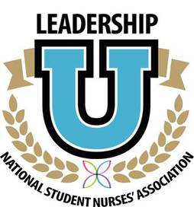
WE ARE SEEKING BOARD MEMBERS
We are currently seeking board members for the Student Nurses Association (SNA)! If you’re passionate about making a difference, growing as a leader, and helping shape the future of our organization, this is your opportunity to step forward and get involved. Some positions are currently open and many members of the board are scheduled to GRADUATE in JUNE (Congratulations)! As an active Board Member, you qualify to apply to the NSNA Leadership U!

MEMBERSHIP DRIVE
Have you been considering joining the RUKC-SNA community? Now is the time to join us! We are here to accompany you through your nursing school journey! You will have support, friends, and fun! We are your fellow nursing students!
The RUKC-SNA is part of the Kansas Student Nurses Association and the National Student Nurses Association (NSNA). Imagine all of this networking and support in your new career!

To join, visit www.NSNA.org. Once you complete the membership application and pay the small fee, let us know and we will register you
The Daisy Award for Nursing Students
The DAISY Award for Nursing Students recognizes those who demonstrate exceptional compassion, clinical skill, professionalism, and dedication to patient-centered care. This special honor celebrates students who go above and beyond to make a meaningful difference for patients, families, peers, and the healthcare team. Nominations are now open for the June cohort, and we encourage you to take a moment to recognize a classmate who exemplifies the values of nursing excellence. If you have witnessed a fellow student showing kindness, leadership, teamwork, or outstanding commitment in clinical or the classroom, please submit a nomination and help celebrate their impact. Please note that all nominations must be from the June 2026 Cohort.
Please cast your vote at the RUKC-SNA table on the campus.
Daisy Award for Nursing Instructors
The DAISY Award for Outstanding Nursing Instructors is awarded every June and December. There is one award for the Topeka location and one award for the Overland Park location. Please cast your vote!

Activities:  Garage Sale  Garage sale dates on the OVP Campus:  May 4th & 5th  May 13th & 14th  May 22nd  May 28th  We will continue to have the garage sales throughout each quarter.  Our Little Pantry  We have been filling the pantries at both locations! Remember, when you contribute you earn points! Please feel free to take what you need or donate what you can.  Our free little pantry is open to anyone. If you are hungry, take what you need. If you are able to share, please do.  BBQ Lunch at the OVP location  A catered BBQ lunch will be on site on Wednesday May 6th from 11-1 pm. Cost is $5 for the lunch. You must sign up by May 1st.  DIY Badge Charms  In honor of Nurses Week, we will be making DIY Badge Charms from 12-2pm on May 7th at the OVP campus. Come and make a badge charm!  *while supplies last  THE RUKC-SNA Point System  Our student nurses' association partners up with many area businesses and agencies. Volunteering is one way to give back to the community and earn points. Together we can make a difference in our communities. Together we are better!  Examples of ways to earn points:  Write an article for the Chapter Newsletter  Earn 2 points per article  Volunteer at one of our sponsored events  Earn 1 point per hour of volunteer time (up  to 8 hours per quarter)  Attend Chapter Meetings  Earn 1 point for attending each monthly  chapter meeting  Serve As a member of the Chapter Board of Directors  Earn 2 points per quarter that you serve as a  Member of the Board  Earn 1 point for attendance at each monthly Board of Directors Meeting  (this is for Board Members)  When You Graduate  When you are almost ready to graduate, add up all of your points that you have earned over the quarters that you have been a member of the RUKC-SNA.  NSNA Chapter Leadership Cords  Members who earn 20 points prior to graduation, earn a NSNA Member Cord to wear at pinning and/or graduation plus other great Member items!  For more information about the point system, please visit www.rukc-sna.com or talk to one of the board members. |  |  | 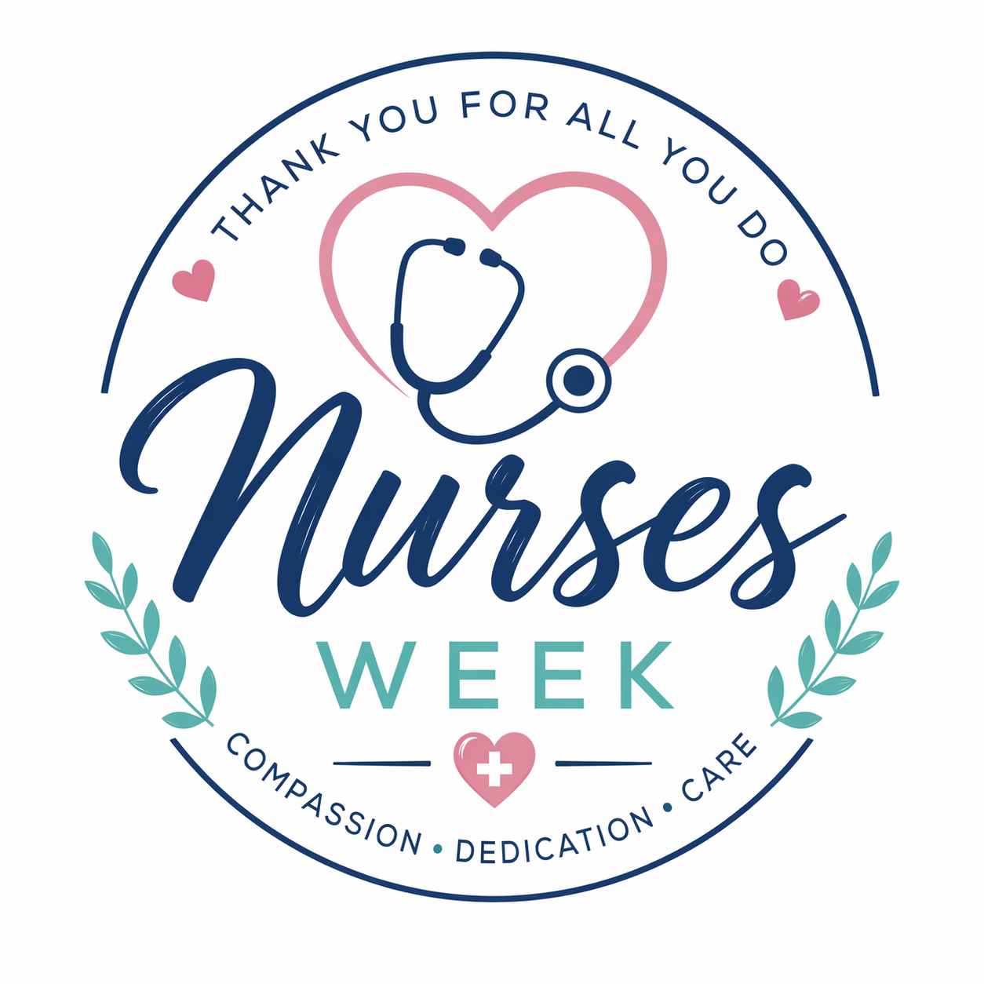  Self-Care Kits  Come make a self-care kit (while supplies last) at the OVP location! May 8th  Bake Sale  Bake sale at the OVP location from 10-12am on May 11th!  Dirty Soda Bar  Dirty soda bar from 11-1pm on May 12th.  In-Person Member Meeting  May 7th at 5pm on the OVP campus. All are welcome to attend.  Cheers to Our Peers Board  Recognize a peer! Take a post-it note and write a message to a peer! Place it on the tri-fold board on the OVP RUKC-SNA table.  The Benefits of Joining the NSNA  There are many reasons to join the NSNA. Joining the National Student Nurses’ Association (NSNA) provides nursing students with valuable opportunities to grow professionally, academically, and personally. Membership offers access to leadership development experiences, scholarships, networking with peers and nurse leaders across the country, and resources that support success in nursing school and beyond. Students can participate in conferences, community health initiatives, and advocacy efforts that strengthen their voice in the future of nursing. Involvement in NSNA also helps build confidence, enhance resumes, and create meaningful connections that can open doors to mentorship and career opportunities after graduation. Being part of NSNA empowers students to become engaged, informed, and influential members of the nursing profession. Members also qualify for numerous discounts.  Succeeding in Nursing School  Succeeding in nursing school requires strong time management, consistent study habits, and a willingness to stay engaged both in and out of the classroom. Nursing students benefit from reviewing material daily, practicing clinical skills regularly, and asking questions early when concepts are unclear. Building supportive relationships with classmates and instructors can make learning more effective and less stressful. It is also important to take care of your physical and mental well-being by getting enough rest, staying organized, and maintaining balance during busy weeks. With persistence, preparation, and a positive mindset, students can develop the knowledge, confidence, and clinical judgment needed to become safe and compassionate nurses.

