
RUKC-SNA
February 2026 News

Membership Drive
Have you been considering joining the RUKC-SNA community? Now is the time to join us! We are here to accompany you through your nursing school journey! You will have support, friends, and fun! We are your fellow nursing students!
The RUKC-SNA is part of the Kansas Student Nurses Association and the National Student Nurses Association (NSNA). Imagine all of this networking and support in your new career!
To join, visit www.NSNA.org. Once you complete the membership application and pay the small fee, let us know and we will register you with the RUKC-SNA for FREE! We are excited to meet you.

Two Locations, One Campus
Meet the Board (OVP)
President: Barbie Eckert
Vice President: Shelby Noyes
Secretary: Zakiyyah Robinette
Treasurer:
Membership Director:
Events Coordinator: Kaila Marshall

Faculty Advisor: Anne Naulty

Meet the Board (Topeka)

President: Dejanah Timley
Vice President: Erin Michel
Secretary:
Treasurer:
Membership Director/Historian: Ayanna Etchsion
Events Coordinator: Sarah Sheets

Faculty Advisor: Sandy Bergman

In order to fully represent all of the students, we have “split” the Board, which are reflected in the revised by-laws. The board members from each campus will work together in order to provide continuity. We recognize that the student needs from each campus may vary and change. Opportunities may also arise at each campus. Please remember that all activities are open to members from both locations!
We are one in spirit and purpose.

Success in Nursing School
Success in nursing school requires a combination of effective study habits, resilience, and strong self-care. Staying organized and managing time well are essential, as coursework, clinicals, and exams can quickly become overwhelming; using planners or digital calendars can help keep priorities clear. Active learning strategies—such as practice questions, concept maps, and teaching material to others—are more effective than passive reading and better prepare students for NCLEX-style exams. Seeking support early is also key; forming study groups, communicating with faculty, and using tutoring or academic resources can prevent small challenges from becoming setbacks. Equally important is caring for your physical and mental health by getting adequate sleep, eating well, and finding healthy ways to manage stress. Finally, maintaining a growth mindset—viewing mistakes as learning opportunities and staying focused on the goal of becoming a safe, compassionate nurse—can help students persevere through the demands of nursing school.

We asked “Why you Want to Become a RN?” and this is what you wrote:

“To be the difference in someone else’s life.”

“For myself, kids, family-Love helping people.”

“I want to help people who need it.”

“I want to be able to advocate for those who don’t have a voice.”
“I want to give back to my community. One healthcare crew saved my life and so I want to give back to do that for others.’

“Take better care of my own family, help others become healthy, do something that makes a difference, and get paid for what I am worth.”

“I want to become a nurse because it is my passion to help people. Becoming a nurse will also bless me to bless other family, friends, and my daughter.”

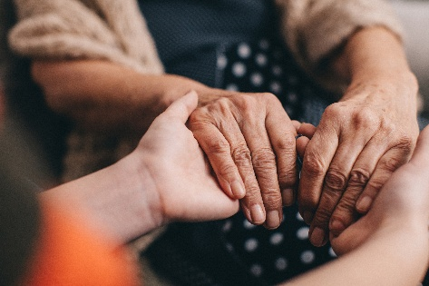
Nursing school is challenging because the work you are preparing to do truly matters. Every long night of studying, every difficult exam, and every moment of self-doubt is shaping you into a nurse who will make a difference in someone’s life when they need it most. You will not always feel confident, but growth often happens in the moments when you choose to keep going anyway. Remember that compassion, perseverance, and integrity cannot be measured by a test score, yet they are the heart of nursing. Trust the process, believe in your ability to learn and grow, and know that one day a patient will be better because you didn’t give up.

Why Simulation?
Simulation is common in law enforcement, firefighting, and mass casualty training. It has become one of the most powerful teaching tools in nursing education. Simulation allows nursing students to learn by caring for simulated patients in a safe learning environment. Skills such as managing a rapid response, administering medications, or communicating with a distressed patient, without the fear of harming an actual person, occurs in simulation. Students can ask questions, make mistakes, and learn from them, which builds confidence and clinical judgment long before stepping onto the unit.
Simulation also strengthens critical thinking, teamwork, and communication. These skills are essential on busy hospital floors. Debriefing after simulations allows students to reflect on their decisions, understand what went well, and identify areas for growth. For nursing students, simulation is more than practice—it’s preparation for the fast-paced, high-stakes reality of patient care and a bridge between learning and becoming a confident, competent nurse.

A Letter from the Topeka President

Hello everyone! My name is Dejanah Timley, and I am honored to serve as the President of the Topeka Student Nurses Association (SNA) location. Being part of SNA has been an incredibly rewarding experience, allowing me to grow as a leader while connecting with fellow nursing students who share a passion for learning, service, and advocacy within our profession.
As president, I am excited to help strengthen our chapter through collaboration, community involvement, professional development opportunities, and support for our members throughout their nursing journey. My goal is to foster an inclusive and encouraging environment where every student feels empowered to succeed.
After graduation, I hope to pursue a career as a NICU or Pediatric nurse, caring for some of the most vulnerable patients and supporting families during critical moments. I am deeply motivated by the impact compassionate, evidence-based nursing care can have on children and their futures.
I look forward to an amazing year with our SNA chapter and am grateful for the opportunity to serve and grow alongside all of you!"
Dejanah Timley

A Letter from the OVP President

It is with great excitement that I welcome you to a new and inspiring year with the Rasmussen University Student Nursing Association! I am committed to representing SNA, alongside our board members and students, to advance our nursing careers.
I am eager to help continue a tradition that empowers every member to grow personally and professionally. SNA is committed to advancing nursing education by offering programs that support students’ core interests and promote their professional and personal development, allowing them to deliver high-quality health care. Together, we will embrace opportunities to strengthen our clinical skills, advocate for patient care, and encourage positive and collaborative relationships within our cohorts.
This year, we have planned an engaging calendar of events, including a meet-the-board event, a garage sale, games, and educational events. These are not only a chance to learn but also to connect with peers, faculty, and professionals who share your passion for nursing.
SO COME JOIN US!! I encourage each of you to get involved, share your ideas, and help shape the direction of our association. Your voice and participation are vital to our success!! Please feel free to reach out to me or any of our board members. We are here to support you and ensure that your time in the Student Nurses Association is rewarding and impactful.
Thank you for your attention to SNA. I look forward to working with you and seeing what we can accomplish together this year!

rukc-sna official constituent status
for the 2026-2027 year has been submitted to the nsna

Warm regards,
Barbie Eckert

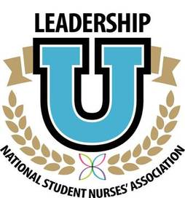
Serving as a RUKC-SNA Board Member qualifies you to join the NSNA Leadership University.

Welcome to our new Board Members!
If you are interested in being a part of the Board of Directors, please contact any members of the current Board or one of our Faculty Advisors!

RUKCSNA@Yahoo.com
THE RUKC-SNA Point System

We represent the Topeka and Overland Park Campuses.

Get active in the community!
Our student nurses' association partners up with many area businesses and agencies. Volunteering is one way to give back to the community and earn points. Together we can make a difference in our communities. Together we are better!

Examples of ways to earn points:

Write an article for the Chapter Newsletter
Earn 2 points per article
Volunteer at one of our sponsored events
Earn 1 point per hour of volunteer time (up to 8 hours per quarter)
Attend Chapter Meetings
Earn 1 point for attending each monthly chapter meeting
Serve As a member of the Chapter Board of Directors
Earn 2 points per quarter that you serve as a Member of the Board
Earn 1 point for attendance at each monthly Board of Directors Meeting
(this is for Board Members)
Each quarter, your points are added up. The levels are:
Above 14 points earned: GOLD LEADERSHIP STATUS
8 – 13 points earned: SILVER LEADERSHIP STATUS
6-12 points earned: BRONZE LEADERSHIP STATUS
As you reach different levels, you not only receive a certificate of achievement, however you also can earn other great items!

When You Graduate
When you are almost ready to graduate, add up all of your points that you have earned over the quarters that you have been a member of the RUKC-SNA.
NSNA Chapter Leadership Cords

Members who earn 20 points prior to graduation, earn a NSNA Member Cord to wear at graduation plus other great Member items!

We honor your service and commitment to the chapter and National Organization.

Upcoming Activities and Events

Membership Drive OVP and Topeka: Ongoing

Fill the Little Pantry: OVP and Topeka
Please bring donations to fill the free little pantry. You will earn points and help your fellow students.

Garage Sale on Campus: OVP: Please donate any items related to nursing or nursing school. We are planning to have a GARAGE SALE on February 18th and 19th in the AM. All proceeds will go back to the students through activities! Please bring any donated items by February 10th. Items can be given to the students at the front desk. Thank you!

OVP Week 10 Pizza Party! March 10th. Come join the Board for some pizza!

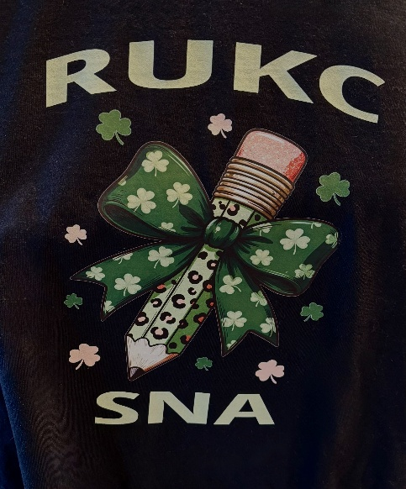
T-Shirt Sales. Black short sleeve T-shirts. Support RUKC-SNA and purchase a T-shirt. Look for the order forms on campus. $15 each. Limited edition. Limited supply.

THE MOOSE IS ON THE LOOSE! Look for Razzy, the Rasmussen Moose Mascot. Razzy is on campus!

We are working on our Spring Golden Egg Hunt. More information to come!

The Next Member Meeting is scheduled for Thursday, February 5th, 2026 at 7pm. It will also be through TEAMS. All members should be receiving an invitation to join RUKC-SNA TEAMS Group through email. Please accept the invitation. Come and see all of the fun activities we have planned!

The RUKC-SNA Board of Directors (Topeka and OVP) meet the 3rd Friday of each month at 5PM. Our last meeting was on January 23^{rd,} and our next meeting is on February 20th at 5PM CST. All meetings are through TEAMS.

If you are interested in joining the Board of Directors, please contact one of our current Board Members for more information!

