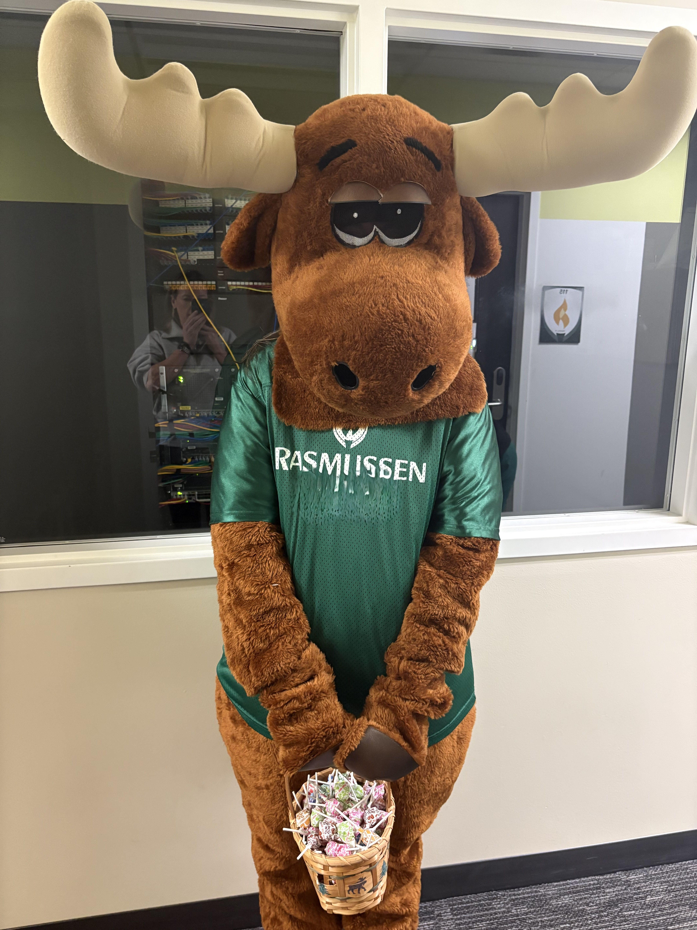

RUKC-SNA Newsletter
March 2026
March 2026

The Moose is on the Loose
SNA has been hosting Razzy, the RU moose! Watch for Razzy to visit your classroom and bring some prizes! Razzy helps to spread school spirit and bring joy. Razzy represents hard work, determination, community service. Make sure you say hello!  Membership Drive  Have you been considering joining the RUKC-SNA community? Now is the time to join us! We are here to accompany you through your nursing school journey! You will have support, friends, and fun! We are your fellow nursing students!  The RUKC-SNA is part of the Kansas Student Nurses Association and the National Student Nurses Association (NSNA). Imagine all of this networking and support in your new career!  To join, visit www.NSNA.org. Once you complete the membership application and pay the small fee, let us know and we will register you with the RUKC-SNA for FREE! We are excited about meeting you.  Joining a Student Nurses Association is more than adding a line to your résumé—it’s about finding your people. Nursing school can feel overwhelming, but being part of an SNA creates a sense of camaraderie that reminds you you’re not doing this alone. Through shared experiences, study sessions, service projects, and leadership opportunities, students are able to build genuine connections with colleagues who understand the stress, the wins, and the late-night studying. That support system boosts confidence, reduces burnout, and helps students grow both personally and professionally. The friendships and mentorship formed within a Student Nurses Association often last well beyond graduation, strengthening not only individual nurses but the profession as a whole. |  | Meet the Board (OVP)  President: Barbie Eckert  Vice President: Shelby Noyes  Secretary: Zakiyyah Robinette  Treasurer: Kenda Gunther  Membership Director: Hiba Solarte  Events Coordinator: Kaila Marshall  Historian: Britney Lee  Faculty Advisor: Anne Naulty  Meet the Board (Topeka)  President: Dejanah Timley  Vice President: Erin Michel  Secretary: Available  Treasurer: Kyle Dutcher  Membership Director/Historian: Ayanna Etchsion  Events Coordinator: Sarah Sheets  Faculty Advisor: Sandy Bergman

Activities:

Coloring Contest
Thank you to everyone who participated in the coloring contests. OVP and Topeka both hosted coloring contests!  Watch for more coloring contests in the future!  Pathway to New Grads with HCA  A HCA representative will be visiting the OVP campus to host the Pathway to New Grads program on March 12th. Covered subjects will include: finding the nurse externship, shadowing opportunities, applying and interviewing, training in nurse bootcamp, and working with a mentor.  Virtual Resume Review with HCA  Coming in April to OVP. What do companies look for in a resume? Come and find out!  Garage Sale  The garage sale was held in OVP on February 25th and 26^{th.} March dates will be announced.  Final Stretch Yoga  RUKC-SNA will be hosting “Final Stretch” yoga during finals week (week 11). Dates to be announced.  Our Little Pantry  We have been filling the pantries at both locations! Remember, when you contribute you earn points! Please feel free to take what you need or donate what you can.  Mini-Moose on the Loose  Find the mini-moose on the loose in OVP and take a picture with him. This earns you points!    Serving as a RUKC-SNA Board Member qualifies you to join the NSNA Leadership University.  Welcome to our new Board Members!  If you are interested in being a part of the Board of Directors, please contact any members of the current Board or one of our Faculty Advisors!  RUKCSNA@Yahoo.com  Time Management in Nursing School  Time management is one of the most important skills for nursing students to develop, as the demands of nursing school can be intense and fast-paced. Balancing clinical rotations, lectures, assignments, exam preparation, and often part-time work requires careful planning and prioritization. Unlike many other fields of study, nursing education combines rigorous academic coursework with hands-on patient care experiences, where being unprepared can directly impact patient safety. Effective time management helps students reduce stress, meet deadlines, and arrive at clinical placements organized and confident. By using tools such as planners, study schedules, and task prioritization strategies, nursing students can build habits that not only support academic success but also prepare them for the real-world responsibilities of professional nursing practice.  THE RUKC-SNA Point System  Our student nurses' association partners up with many area businesses and agencies. Volunteering is one way to give back to the community and earn points. Together we can make a difference in our communities. Together we are better!  Examples of ways to earn points:  Write an article for the Chapter Newsletter  Earn 2 points per article  Volunteer at one of our sponsored events  Earn 1 point per hour of volunteer time (up  to 8 hours per quarter)  Attend Chapter Meetings  Earn 1 point for attending each monthly  chapter meeting  Serve As a member of the Chapter Board of Directors  Earn 2 points per quarter that you serve as a  Member of the Board  Earn 1 point for attendance at each monthly Board of Directors Meeting  (this is for Board Members)  When You Graduate  When you are almost ready to graduate, add up all of your points that you have earned over the quarters that you have been a member of the RUKC-SNA.  NSNA Chapter Leadership Cords  Members who earn 20 points prior to graduation, earn a NSNA Member Cord to wear at pinning and/or graduation plus other great Member items!  For more information about the point system, please visit www.rukc-sna.com or talk to one of the board members. |  |  | Skills Time in The Lab  Have you ever wanted to practice your nursing skills, but feel like there is no time? We will be hosting skills practice hours at OVP. Times and dates TBA.  Winter 26 Shirt Sales  There are 7 shirts available for purchase. Please see the flyers around campus. Proceeds go to the RUKC-SNA.    Practical Strategies for Managing Stress  1. Master Time Management  Create a weekly schedule that includes class time, study sessions, clinical preparation, and personal time. Breaking large assignments into smaller tasks prevents last-minute panic and improves focus.  2. Focus on What You Can Control  You can’t control every clinical scenario, but you can control your preparation. Review procedures ahead of time, ask questions, and seek clarification when needed. Preparation reduces anxiety.  3. Build a Support System  Lean on classmates — they understand your challenges better than anyone else. Study groups can reinforce learning and provide emotional support. Don’t hesitate to reach out to instructors or academic advisors if you’re struggling.  4. Prioritize Self-Care  Sleep, nutrition, and exercise are not luxuries; they are necessities. Even 20 minutes of movement, deep breathing, or journaling can reset your stress response. Chronic exhaustion only magnifies anxiety.  5. Develop Emotional Resilience  Clinical experiences can be emotionally intense. Reflective journaling or speaking with a mentor can help you process difficult moments. Remember: feeling emotional doesn’t mean you’re weak — it means you care.  6. Practice Mindfulness Techniques  Short breathing exercises before exams or clinical shifts can lower heart rate and improve focus. Apps, guided meditations, or simple grounding exercises can be powerful tools during high-pressure moments.  When to Seek Extra Help  If stress begins affecting your sleep, appetite, academic performance, or mental health, reach out to campus counseling services. Seeking help is a sign of professionalism and self-awareness — qualities essential in nursing.    U.S. Holidays & Observances — March & April 2026  March 2026  March 2 (Mon) – Read Across America Day  March 3 (Tue) – Purim (Jewish)  March 4 (Wed) – Holi (Hindu)  March 6 (Fri) – Employee Appreciation Day March 8 (Sun) – Daylight Saving Time Begins March 15 (Sun) – Laylat al-Qadr (Muslim)  March 17 (Tue) – St. Patrick’s Day  March 20 (Fri) – Last day of the W26 Quarter  Spring Equinox  Eid al-Fitr (Muslim)  March 26 (Thu) – Rama Navami (Hindu)  March 29 (Sun) – Palm Sunday (Christian)  April 2026  April 1 (Wed) – April Fools’ Day  Passover Begins (Jewish)  April 3 (Fri) – Good Friday (Christian)  April 5 (Sun) – Easter Sunday (Christian)  April 6 (Monday)- Spring Quarter benginl  April 9 (Thu) – Passover Final Day (Jewish)  April 10 (Fri) – Orthodox Good Friday (Orthodox)  April 12 (Sun) – Orthodox Easter (Orthodox) April 13 (Mon) – Thomas Jefferson’s Birthday  April 14 (Tue) – National Library Workers Day  April 14 (Tue) – Yom HaShoah (Jewish)  April 15 (Wed) – Tax Day (Observance)  April 22 (Wed) – Earth Day (Observance)  – Administrative Professionals Day  April 23 (Thu) – Take Our Daughters and Sons to Work Day  April 24 (Fri) – Arbor Day
 | You can easily change the formatting of selected text in the document text by choosing a look for the selected text from the Styles gallery on the Home tab.

