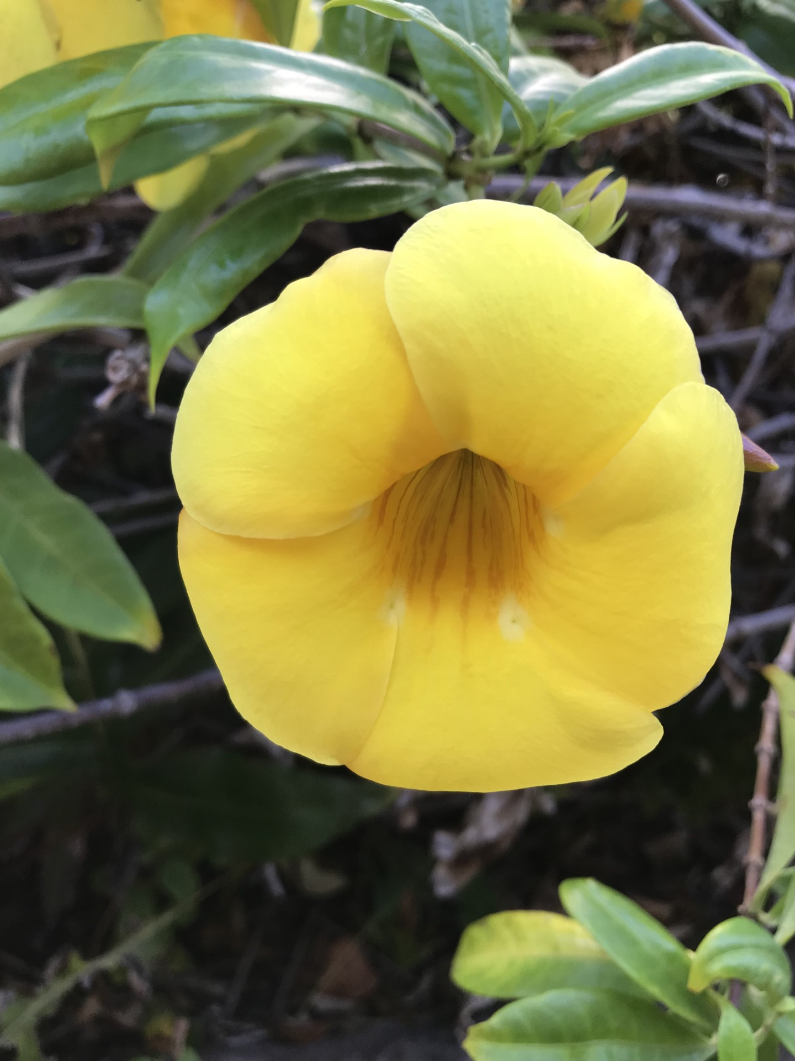
RUKC-SNA Newsletter
April 2026
March 2026

Welcome to the Spring 26 Quarter Loose
Welcome to Spring 26! 🩺 This is a fresh opportunity to build confidence, strengthen your clinical thinking, and continue developing the knowledge and compassion that define professional nursing practice. Each lesson, skill check-off, and patient interaction brings you one step closer to your goal of making a meaningful difference in the lives of others. Stay curious, support one another, and remember that growth often happens just outside your comfort zone.  WE ARE SEEKING BOARD MEMBERS  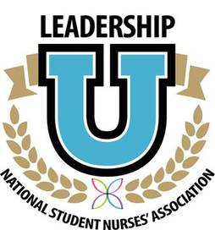  We are currently seeking board members for the Student Nurses Association (SNA)! If you’re passionate about making a difference, growing as a leader, and helping shape the future of our organization, this is your opportunity to step forward and get involved. Some positions are currently open and many members of the board are scheduled to GRADUATE in JUNE (Congratulations)! As an active Board Member, you qualify to apply to the NSNA Leadership U!  Membership Drive  Have you been considering joining the RUKC-SNA community? Now is the time to join us! We are here to accompany you through your nursing school journey! You will have support, friends, and fun! We are your fellow nursing students!  The RUKC-SNA is part of the Kansas Student Nurses Association and the National Student Nurses Association (NSNA). Imagine all of this networking and support in your new career!  To join, visit www.NSNA.org. Once you complete the membership application and pay the small fee, let us know and we will register you with the RUKC-SNA for FREE! We are excited about meeting you.  Joining a Student Nurses Association is more than adding a line to your résumé—it’s about finding your people. Nursing school can feel overwhelming, but being part of an SNA creates a sense of camaraderie that reminds you you’re not doing this alone. Through shared experiences, study sessions, service projects, and leadership opportunities, students are able to build genuine connections with colleagues who understand the stress, the wins, and the late-night studying. That support system boosts confidence, reduces burnout, and helps students grow both personally and professionally. The friendships and mentorship formed within a Student Nurses Association often last well beyond graduation, strengthening not only individual nurses but the profession as a whole. |  | Meet the Board (OVP)  President: Barbie Eckert  Vice President: Shelby Noyes  Secretary: Zakiyyah Robinette  Treasurer: Kendra Guenther  Membership Director: Hiba Solarte  Events Coordinator: OPEN  Historian: OPEN  Faculty Advisor: Anne Naulty  Meet the Board (Topeka)  President: Dejanah Timley  Vice President: Erin Michel  Secretary: Available  Treasurer: Kyle Dutcher  Membership Director/Historian: Ayanna Etchsion  Events Coordinator: Sarah Sheets  Faculty Advisor: Sandy Bergman


Activities:
Garage Sale  The garage sale was held in OVP on April 6th and 7th. We will hold additional sales throughout the quarter.  Our Little Pantry  We have been filling the pantries at both locations! Remember, when you contribute you earn points! Please feel free to take what you need or donate what you can.  Our free little pantry is open to anyone. If you are hungry, take what you need. If you are able to share, please do.  Mini-Moose on the Loose  Find the mini-moose on the loose in OVP and take a picture with him. This earns you points!  -=Serving as a RUKC-SNA Board Member qualifies you to join the NSNA Leadership University.  If you are interested in being a part of the Board of Directors, please contact any members of the current Board or one of our Faculty Advisors!  RUKCSNA@Yahoo.com  Time Management in Nursing School  By: Anne Naulty, MSN, RN, PCCN-k  Time management is a topic on many of our minds. We may ask ourselves, You may ask, “How do I even begin to get everything done?” If you find yourself asking this question often, know that you are not alone.  Nurses will confirm, nursing school is hard- Anything worthwhile in life, usually is. When enrolled in an excelled program, life becomes a little more challenging. It is important to take time to learn the material you are being taught. Information stacks and becomes more intense. We are building a nursing house of information. Each class symbolizes a brick in the house. We want this house to be strong so it does not sway in times of harsh weather.  In order to build a strong nursing information house, the builder (you), must remember to care for him/herself. There is an old saying, “we cannot give away what we do not have.” If you want to be able to give compassion, you must first have compassion for yourself. We must first learn to fill our cup before we can share with others. This thought follows Maslow’s Hierarchy of Needs. It first involves making time to care for our basic needs- sleep, nutritious food, time to unwind, clothing, etc. We must sometimes schedule this time. This is how we are able to learn most effectively. Caring for oneself means deciding what is important and setting time aside for these activities. It is important to remember that quality time is more important than quantity. It is important to remember that YOU MATTER.  We must then set our intentions. Let’s think of intentions as plans. What is important to us? What are we trying to accomplish? The answers to these questions are very important as we state our intentions. It is the “why.” In times of harsh weather, our intentions are what help us remember what inspired us to begin the journey. Remember the harsh weather will pass and you will be standing tall. You are among many builders who will help to shelter you from the storms. You must focus. Many tasks can be completed in less time if we are active in our intentions.  THE RUKC-SNA Point System  Our student nurses' association partners up with many area businesses and agencies. Volunteering is one way to give back to the community and earn points. Together we can make a difference in our communities. Together we are better!  Examples of ways to earn points:  Write an article for the Chapter Newsletter  Earn 2 points per article  Volunteer at one of our sponsored events  Earn 1 point per hour of volunteer time (up  to 8 hours per quarter)  Attend Chapter Meetings  Earn 1 point for attending each monthly  chapter meeting  Serve As a member of the Chapter Board of Directors  Earn 2 points per quarter that you serve as a  Member of the Board  Earn 1 point for attendance at each monthly Board of Directors Meeting  (this is for Board Members)  When You Graduate  When you are almost ready to graduate, add up all of your points that you have earned over the quarters that you have been a member of the RUKC-SNA.  NSNA Chapter Leadership Cords  Members who earn 20 points prior to graduation, earn a NSNA Member Cord to wear at pinning and/or graduation plus other great Member items!  For more information about the point system, please visit www.rukc-sna.com or talk to one of the board members.  April 2026  April 6 (Monday)- Spring Quarter begins  SNA Garage Sale  April 7 (Tuesday)- SNA Garage Sale  April 13 (Mon) – Thomas Jefferson’s Birthday  April 14 (Tue) – National Library Workers Day |  |  | Skills Time in The Lab  Have you ever wanted to practice your nursing skills, but feel like there is no time? We will be hosting skills practice hours at OVP. Times and dates TBA.  Spring 26 Shirt Sales  Spring SNA T-Shirt sales will start in week 3! Our new designs are amazing!  Member Meetings  SNA member meetings are held on the 2nd Thursday of each month at 5PM.  We are moving the member meetings back on campus! Join us for dinner, fun, facts, and friends.  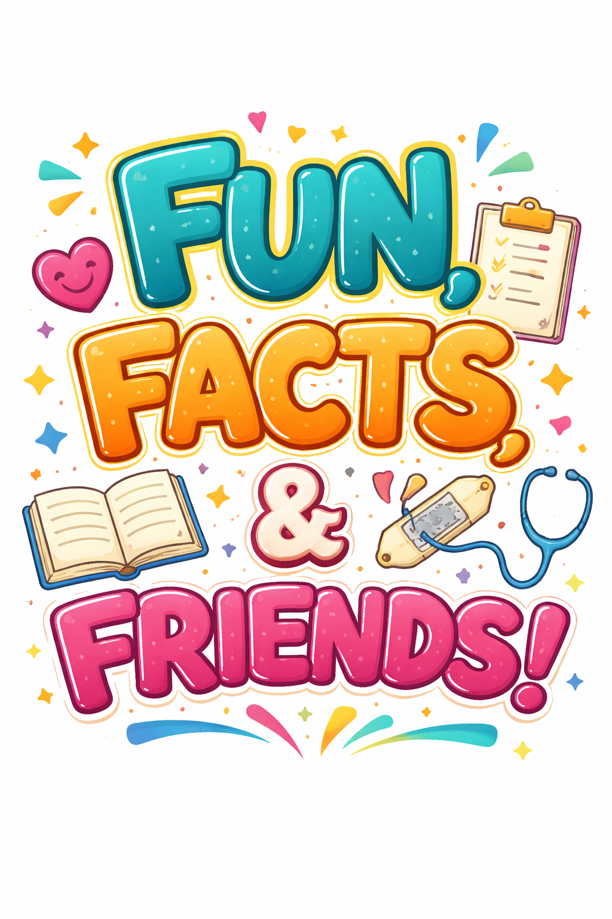  Now that we have our intentions set, we must come up with the plan- creating our schedule. Keep in mind there are only 24 hours in a day and 7 days in a week.  - Schedule the “have to’s.” These are the activities that are necessary in order to complete our intention. These activities include class time, clinical time, lab time, etc. Remember to include travel time and be realistic. There is a lot of construction in Kansas City right now, so we must give ourselves extra time.  - Schedule time for sleep. Learning cannot occur if we do not give our minds time to rest and repair.  - Write down assignments and time to complete. Assignments help prepare nursing students for exams. They help the student learn the information and practice using it. The assignments are also part of the course grade and make up approximately 20% of it. Late assignments lose points and assignments submitted more than a week late do not earn any points. On time submission is a mandatory lesson in nursing. Breaking down large assignments into smaller tasks may also be beneficial.  - Schedule study time. Every hour of didactic class requires 3 hours of study time. Study time can include module time, reading, reviewing class notes, answering practice questions, and more!  - Schedule some fun time.  When to Seek Extra Help  If stress begins affecting your sleep, appetite, academic performance, or mental health, reach out to campus counseling services. Seeking help is a sign of professionalism and self-awareness — qualities essential in nursing.  April 15 (Wed) – Tax Day (Observance)  April 22 (Wed) – Earth Day (Observance)  – Administrative Professionals Day  April 23 (Thu) – Take Our Daughters and Sons to Work Day  April 24 (Fri) – Arbor Day  April 27: First day of week 4: Exam Week    Earth Facts: Celebrating Earth Day  About 71% of Earth’s surface is covered by water, mostly oceans. 96.5% of ocean water is made from H2O, and the remainder is a mixture of dissolved salts, minerals, and gases. These include sodium chloride (NaCl), magnesium, sulfate, calcium, zinc, calcium, and potassium.  When humans swim in the ocean, transdermal absorption (percutaneous absorption) occurs. This means that we are able to absorb some of the minerals from ocean water. Scientists are not sure the amount that is absorbed, however studies show ocean water can significantly help treat psoriasis, eczema, edema, dry skin, and much more (Sissons, 2022)! Deep sea water has also been found to reduce immunoglobulin E (IgE) and histamine (2022).  Deep sea water is most beneficial because the sun does not encourage bacterial and plankton growth. This means that it maintains more nutrients.  Living near the ocean also has been shown to improve health and prolong life expectancy (Neuroscience News, 2025).  The medical benefits of seawater and ocean life continue to be studied.  References  Neuroscience News (2025). Living near the ocean may add years to your life. Retrieved from www.neurosciencenews.com  Sissone, B. (2022). Is saltwater good for the skin? What to know. Retrieved from www.medicalnewstoday.com
 | You can easily change the formatting of selected text in the document text by choosing a look for the selected text from the Styles gallery on the Home tab.

